To create a cluster we need eksctl,kubectl & AWS cli.
If you take amazon linux by default you will get AWS cli as pre-installed.
To install eksctl as per the architecture of the machine we need to install. Here ours is amd. Got to this link and download the which version you need Set up kubectl and eksctl - Amazon EKS .
To install eksctl go to this link Installation - eksctl and download as per your os requirement.
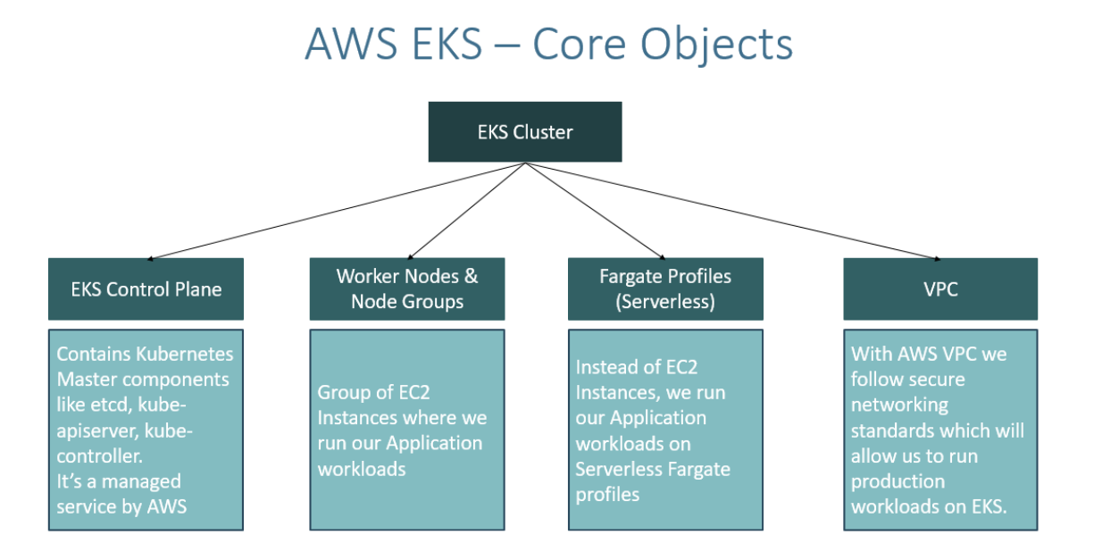
To use Fargate profile, we need atleast one private subnet that means we need VPC.

